NVIDIA Week 8 — Task 1: Strategy & Transformation Thesis
Oct 13, 2026 · @Dimi

What this package delivers
Task 1 owns the argument the whole delivery rests on: NVIDIA's moat funds its own attackers. Its ~75% gross margin is the business case for every custom chip its largest customers build.
Lock this thesis wording across the brief, the log and the video:
- Transformation: "From gaming-GPU vendor to full-stack AI computing platform."
- Verdict: "NVIDIA is a genuine digital transformation — its competitive boundary moved from gaming graphics to data-center computing — whose durability now depends on keeping CUDA the default while its largest customers build substitutes."
- Finding 1: The moat was built before the market, not for it.
- Finding 2: Software lock-in, not the chip alone, converted demand into value capture.
- Finding 3: The binding constraint is concentration against substitutes.
This is Task 1's full output, built against rubric 8.39–8.44 and Winning Map v2. Group 3's split: 1 Strategy & Transformation Thesis · 2 Business Economics & AI Moats · 3 Roadmap, KPIs & Evidence · 4 Executive Brief & Presentation · 5 Integration, all members.
Scope assumption: the split does not say who owns which framework. I placed 1, 2 and 8 in Task 1, because those three decide the thesis. Frameworks 3–5 go to Task 2 (economics, moats, maturity) and 6–7 to Task 3 (roadmap, KPIs). If the group splits them differently, only row 8 moves.
- Evidence Log rows 1, 2 and 8, final and copy-paste ready, every figure from a named primary source.
- Falsification test from Map §1, run on six fiscal years: passed, with one honest limit that strengthens the recommendation.
- The causal chain arrow by arrow, each arrow tied to a log row. This is the synthesis Task 4 writes into the brief's Analysis section and the video's 2:30–3:30 segment.
- Counterarguments at full strength, with answers.
- The bar rows 3–7 must clear, with verified leads, so Tasks 2 and 3 close the chain.
- My items for the Task 5 checklist and my LMS contribution statement.
Three upgrades to v2 come out of the evidence. Each one is flagged where it lands:
- Row 1 is more precise: two of the three five-year tests changed (profit mechanism, competitive boundary). The revenue model stayed transactional. That gap is the hinge of the whole synthesis.
- New boundary evidence: in May 2026 NVIDIA stopped reporting Gaming as its own line. The company redrew its own map.
- The chain's weakest arrow is fixed: "value capture → concentration" was correlation. The causal link is margin (motive) × customer scale (means) → substitutes. The proof case: OpenAI committed 10 GW to NVIDIA and 10 GW to its own Broadcom chips 21 days apart.
This edition also merges an outside verification review. Its precision fixes are in the log and the checklists. The board-facing language stays unhedged, because the rubric grades hedging as a weakness.

Evidence Log rows 1, 2 and 8 (paste-ready after your source check)
All three verdicts hold on the evidence. Each row becomes final only after you open every cited source, as the AI policy requires. After that check, paste them as they stand. Rows 3–7 belong to Tasks 2 and 3.
Framework | Verdict | Evidence | Source
1. DT Classification | Digital Transformation, not digitalization. Within five years NVIDIA's profit mechanism and competitive boundary both changed: it now sells data-center AI systems, not gaming chips. Its revenue model stayed transactional. | Data Center went from $6.70B of $16.68B revenue (40%) in FY2021, when Gaming ($7.76B) was still the largest platform, to $193.7B of $215.9B (90%) in FY2026. GAAP gross margin went from 62.3% to 71.1% (75.0% in Q2 FY2027). Networking, a business NVIDIA did not have before buying Mellanox for $7B in 2020, reached $31.4B in FY2026. In May 2026 NVIDIA stopped reporting Gaming as its own line, moving to "a new reporting framework that better reflects its current and future growth drivers." The 10-K now calls NVIDIA "a data center scale AI infrastructure company." | NVIDIA Q4 FY2021 Earnings Release (Feb 24, 2021); NVIDIA Q4 FY2026 Earnings Release (Feb 25, 2026); CFO Commentary Q4 FY2026, Exh. 99.2 to Form 8-K (Feb 25, 2026); NVIDIA Q1 FY2027 Earnings Release (May 20, 2026); NVIDIA Q2 FY2027 Earnings Release (Aug 26, 2026); NVIDIA FY2026 Form 10-K, Item 1 (filed Feb 25, 2026); "NVIDIA Completes Acquisition of Mellanox" press release (Apr 27, 2020)
2. Platform / Pipeline | A pipeline with platform-grade lock-in, not a matching platform. NVIDIA earns at the point of hardware sale and gives away the developer ecosystem that makes the hardware hard to leave. | CUDA "runs on all NVIDIA GPUs." Developers using CUDA and NVIDIA tools went from 2.2M (FY2021 10-K) to 4.7M (FY2024) to 7.5M (FY2026). Supported applications went from about 600 to 3,500 to 6,000. NVIDIA does not match or price exchanges between developers and GPU buyers. Its direct software revenue was "annualizing at $1.5 billion" in Q3 FY2025, about 1% of revenue. The network effect is indirect and cross-side: developers → libraries and apps → value of NVIDIA hardware → installed base → developers. It is monetized on one side only. | NVIDIA FY2021 Form 10-K, Item 1 (FY ended Jan 31, 2021); NVIDIA FY2024 Form 10-K, Item 1 (filed Feb 21, 2024); NVIDIA FY2026 Form 10-K, Item 1 (filed Feb 25, 2026); NVIDIA Q3 FY2025 Earnings Call, C. Kress remarks (Nov 20, 2024)
8. Case Pattern Match | Successful reinvention through an ecosystem pivot: capability built ahead of demand. It is the mirror image of GE Digital, which announced its ambition ahead of its capability. | NVIDIA built for 16 years before AI paid off. CUDA was unveiled in Nov 2006. AlexNet was trained "on two GTX 580 3GB GPUs" in 2012. cuDNN followed in Sept 2014 and DGX-1 in Apr 2016. Data Center first beat Gaming for a full year in FY2023 ($15.01B vs $9.07B). GE Digital ran the reverse. Immelt set the goal of a "top 10 software company by 2020" and $15B in software sales. By Dec 2018, GE was moving GE Digital and Predix into a separate company with $1.2B of annual software revenue, about 8% of that target. | Digital Engineering 24/7, "NVIDIA Unveils CUDA" (Nov 2006, secondary); Krizhevsky, Sutskever & Hinton, NIPS 2012; NVIDIA Developer Blog, cuDNN launch (Sept 7, 2014); NVIDIA DGX-1 press release (Apr 5, 2016); NVIDIA Q4 FY2023 Earnings Release (Feb 22, 2023); IndustryWeek/AFP, "GE Sees $15 Billion in Software Sales in Digital Transformation" (Feb 29, 2016); SDxCentral, "GE Spins Off Its Digital Business Including Predix" (Dec 17, 2018)
Before submitting (AI-policy requirement):
- Open each filing and check every figure yourself. Press Ctrl-F for "7.5 million", "4.7 million", "2.2 million", "data center scale" and "runs on all NVIDIA GPUs".
- Check that the developer count means the same thing in all three 10-Ks ("developers using CUDA and our other software tools"). If the definition changed, say so in row 2; otherwise the 2.2M → 7.5M growth is not comparable.
- Add the page number to each 10-K citation (for example "FY2026 Form 10-K, Item 1, p. 4"). I could not read the page footers.
- Check the FY2021 10-K filing date on EDGAR. I confirmed its fiscal year end, not its filing date.
- The $1.5B software quote comes from a Nasdaq-hosted transcript. Swap in NVIDIA's own transcript (investor.nvidia.com) before citing it.
- Keep fiscal labels exact. The 75.0% gross margin is a Q2 FY2027 quarter, not a fiscal year; the 73.2% is our calculation, not NVIDIA's.
- Never name the anonymous 22% and 14% customers. They are direct buyers, not necessarily the end users.
Row 8 specifically: if the Week 8 course reading covers GE Digital, cite it in place of the trade press; the course's own case beats SDxCentral. Replace the secondary CUDA source with NVIDIA's original Nov 2006 release (newsroom archive or Factiva).
Ratios computed from the releases: 6.70 / 16.68 = 40.2%; 193.7 / 215.9 = 89.7%; 1.5 / (4 × 35.1 Q3 FY2025 revenue) ≈ 1.1%.

Falsification test: passed, with one limit
Result: the verdict stands. Map §1 said that Data Center growth without matching margin expansion would turn the verdict into "demand-driven hardware cycle." The data show the opposite. Gross margin rose from 62.3% to 75.0% (Q2 FY2027) as Data Center's share of revenue went from 40% to 90%.
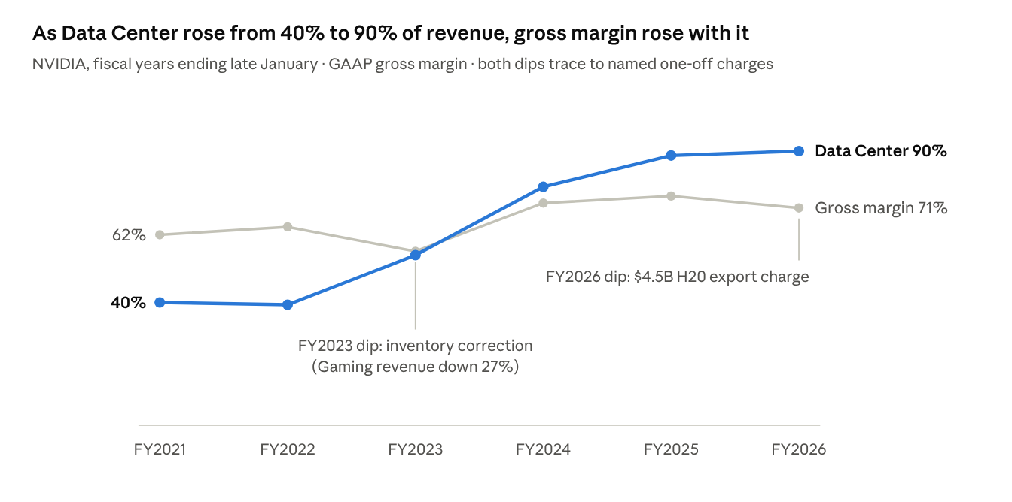
NVIDIA Q4 earnings releases FY2021–FY2026 (Data Center and total revenue, GAAP gross margin) · H20 charge: FY2026 Form 10-K
The two dips do not break the pattern. Each one traces to a named, one-off charge, not to falling prices. FY2023 coincided with an inventory correction (Gaming down 27%). FY2026 absorbed the $4.5B H20 charge disclosed in the 10-K; without it, the FY2026 margin would be about 73%.
The limit, stated honestly: rising margins fit lock-in, but they also fit scarcity. When supply is short, any seller can raise prices. Public data cannot tell the two apart. That gap is not a weakness in our case. It is the case. If NVIDIA's own board cannot tell lock-in from scarcity using the metrics it reports, it needs the leading indicator in our recommendation. The test's limit links straight to Finding 3 and the 90-day action.
Analyst calculation, not a company-reported figure: (0.711 × 215.9 + 4.5) / 215.9 = 73.2%. This assumes the full charge sat in cost of revenue; Task 2 should confirm this in the FY2026 10-K MD&A.

Causal-pattern summary (Task 4 writes from this)
The structural pattern: NVIDIA's moat funds its own attackers. The lock-in that produced its margins is the same thing that motivates its biggest customers to replace it. This is a causal chain, not three findings that happen to share a company.
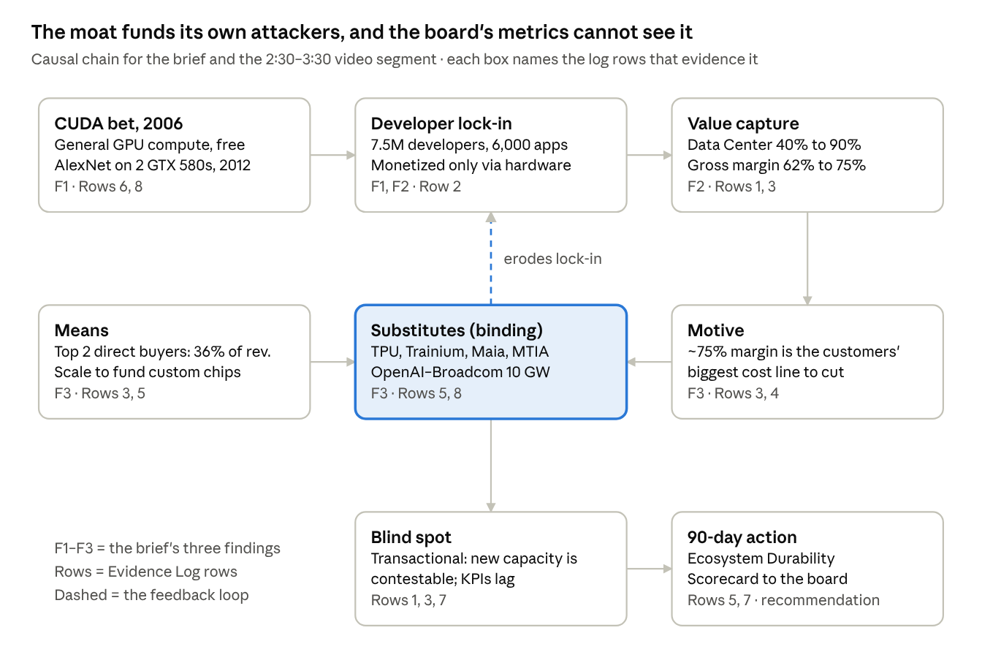
Causal chain · 8 links, 1 feedback loop · replaces Winning Map v2 §5
How the chain runs, in board language (for the brief's Analysis section and the video's 2:30–3:30 segment):
- NVIDIA built general-purpose GPU computing in 2006, six years before deep learning arrived on its hardware. It gave the software away, and 7.5 million developers built on it. (Finding 1)
- That ecosystem let NVIDIA turn the AI boom into profit, not just volume: Data Center grew from 40% to 90% of revenue while gross margin rose to 75%. (Finding 2)
- That margin is now the largest cost line for the few customers who matter. Two direct buyers account for 36% of revenue, and the 10-K estimates that some indirect customers each exceed 10%. They have the motive (the margin) and the means (the scale) to build alternatives, and they are: Google, AWS, Microsoft, Meta, and OpenAI with Broadcom. The sharpest case: OpenAI signed for at least 10 GW of NVIDIA systems on Sept 22, 2025, and for 10 GW of its own chips with Broadcom 21 days later. (Finding 3, the binding constraint)
- Revenue is predominantly transactional. Even the largest commitments are letters of intent, not lock-in: each generation's new capacity is contestable. Erosion will show first in where new workloads land, a number NVIDIA does not report and, as far as its filings show, does not put before its board. Revenue, still up 106% in Q2 FY2027, will show it about a year late. (Hence the recommendation)
What changed from Map v2 §5, and why: v2 ran "value capture → demand concentrates → customers fund substitutes." The first arrow is not causal. Lock-in did not cause hyperscalers to be large. The fix splits it into motive (NVIDIA's margin, caused by lock-in) and means (customer scale, an outside fact). They meet at the substitutes box. That is now the only arrow that needs two inputs, and both have log rows.
One line for the presenter to land: "NVIDIA's margin is its customers' R&D budget."
Finding order is unchanged (Map §4). One wording upgrade for Finding 1, to confirm as a team: "The moat was built before the market, not for it."

Counterarguments at full strength (rows 1–2)
The two rows survive four serious objections. Two of them force sharper wording, which is already in the rows above.
Objection | Strongest version | Answer | Effect on the log
"Market expansion, not transformation" (row 1) | An H100 is still a GPU, from the same architecture line as a GeForce card. Selling the same product to a new segment is Ansoff market development. Calling it DT inflates the term. | What NVIDIA sells and who buys it both changed. A $31.4B networking line did not exist before the 2020 Mellanox deal. Two direct customers now account for 36% of revenue (22% and 14%, FY2026 10-K). Management also redrew its own reporting map in May 2026, which corroborates the shift but would not prove it alone. A product line, a buyer base and a self-definition all moved, not just a segment. | None. The verdict holds.
"The revenue model never changed" (row 1) | NVIDIA still sells hardware one transaction at a time, just as it did in 1999. If the revenue model is unchanged, the five-year test is only partly met. | Conceded, and written into the verdict. The test asks whether the revenue model, profit mechanism or competitive boundary changed. Two of three did. The unchanged one is the most important finding in the log: revenue stays predominantly transactional. Even where multi-year commitments exist, such as OpenAI's 10 GW letter of intent with NVIDIA, each generation's new capacity is contestable. | Verdict made more precise. This becomes the hinge of the causal chain.
"CUDA is a platform, like Windows" (row 2) | Parker and Van Alstyne treat operating systems as textbook two-sided platforms: developers on one side, users on the other, indirect network effects in between. CUDA has the same structure, so "pipeline" is a misclassification. | The network-effect structure is platform-like, and row 2 says so. The economics are pipeline. Microsoft licensed Windows to both sides of that market. NVIDIA charges developers nothing for CUDA, does not intermediate exchanges, and earns about 1% of revenue from software. Value is captured only at the hardware sale. | Verdict reworded to "pipeline with platform-grade lock-in".
"It was luck" (feeds Finding 1) | NVIDIA did not foresee deep learning. CUDA targeted scientific HPC. AlexNet's authors, outsiders, found the fit in 2012, and NVIDIA's AI library (cuDNN) came only in September 2014. | Partly true, and the strength of the answer is in the timing. The bet was on general-purpose GPU computing (CUDA, Nov 2006), not on AI. AlexNet ran on two consumer NVIDIA GTX 580 cards six years later. NVIDIA then shipped cuDNN within about two years, DGX-1 in April 2016 and the first unit to OpenAI that August. | Recommended framing for Finding 1: "The moat was built before the market, not for it." The group confirms before the wording is locked.

Rows 3–7: the bar for Tasks 2 and 3
Each row must close one arrow of the causal chain, or the thesis breaks. The verdicts belong to the Task 2 and Task 3 owners, as the AI policy requires. The leads below are primary-source facts they can verify and use.
Row · task | The row must establish | Verified leads (document, date) | Gap or flag
3. Revenue architecture · Task 2 | Transactional revenue with rising concentration. CAC:LTV marked "insufficient public data", with a proxy. | "Sales to one direct customer represented 22% of total revenue"; another 14% (FY2026 Form 10-K, filed Feb 25, 2026). FY2025: Customers A, B, C at 12%, 11%, 11% (FY2025 Form 10-K, filed Feb 26, 2025). Software, service and support "annualizing at $1.5 billion" (Q3 FY2025 call, Nov 20, 2024). | The CAC:LTV proxy: revenue per top direct customer ($215.9B × 22% ≈ $47.5B a year). The strongest proxy for LTV is the number of chip generations a customer stays. Flag: direct customers may be system builders (ODMs, distributors) buying for end users. Do not call the 22% customer a hyperscaler unless a source says so.
4. AI moats & portfolio · Task 2 | The moat is silicon + software + networking, integrated. Built in-house, extended by buying, made by partners. H1/H2/H3 placement. | Mellanox completed for "a transaction value of $7 billion" (NVIDIA release, Apr 27, 2020). Networking $31.4B FY2026 vs $13.0B FY2025 (CFO Commentary Q4 FY2026, Feb 25, 2026). Q1 FY2027 networking $14.8B, up 199% (Q1 FY2027 release, May 20, 2026). "Paid licenses to NVIDIA AI Enterprise" (FY2026 10-K, Item 1). | H3 candidates: robotics and autonomous driving, now inside "Edge Computing" (Q2 FY2027 release, Aug 26, 2026).
5. Digital maturity · Task 2 | Score all five Week 5 dimensions 1–5. Name the binding constraint: concentrated demand from customers who build substitutes. | Risk factors: some customers "have in-house expertise and internal development capabilities similar to some of ours" (FY2026 10-K, Item 1A). Plus the substitute leads below. | The thesis needs the binding constraint to be external. If Task 2 scores an internal dimension lowest, the group resolves that before the brief is written, because it changes the recommendation.
6. Roadmap quality · Task 3 | Crawl/Walk/Run honored: software before systems, systems before networking, all before the demand surge. | CUDA unveiled Nov 8, 2006 (secondary: Digital Engineering 24/7). cuDNN: NVIDIA Developer Blog, Sept 7, 2014. DGX-1: "NVIDIA Launches World's First Deep Learning Supercomputer" (Apr 5, 2016). Mellanox completed Apr 27, 2020. Board "retains direct oversight of strategic risks" (2026 Proxy Statement, DEF 14A, filed May 12, 2026). | The same dates sit in row 8; both rows must cite them identically.
7. KPI validity · Task 3 | Public KPIs are lagging financials. The undisclosed leading indicator is CUDA's share of top customers' new AI workloads. | The new framework reports Data Center (compute and networking) and Edge Computing, and defines a Hyperscale sub-market: "public clouds and the world's largest consumer internet companies" (Q1 FY2027 release, May 20, 2026). Gaming is no longer reported separately. Substitutes: Google TPU (Google Cloud Blog, May 19, 2016); AWS Trainium (TechCrunch, Dec 1, 2020, secondary); Azure Maia AI Accelerator (Microsoft Source, Nov 15, 2023); MTIA v1 (Meta AI Blog, May 18, 2023); OpenAI–NVIDIA "letter of intent" for "at least 10 gigawatts" of NVIDIA systems (NVIDIA release, Sept 22, 2025); OpenAI–Broadcom "10 gigawatts of custom AI accelerators" (OpenAI, Oct 13, 2025); Anthropic "up to one million TPUs" (Anthropic, Oct 23, 2025). | Check whether Q2 FY2027 actually disclosed the Hyperscale split. Even if it did, hyperscale revenue is still a lagging metric, so the finding stands. Write "Maia AI Accelerator", not "Maia 100". MTIA v1 is an inference chip.

Task 5: my items for the integration checklist
The brief does not ship until every box below is ticked. Each one maps to a line of the 8.43 rubric. Internal Consistency (10%) and Synthesis (5%) are lost on exactly these checks.
Resolve first (header rule): rubric 8.37 and 8.45 define three roles (Framework Analyst, Brief Writer, Presenter) and require each member's name and role in the brief header. Group 3 runs five tasks. Agree on one header format now, for example "Dimitrius — Strategy & Transformation Thesis", and confirm with the instructor that the split is accepted.
Where caveats live: caveats, definitions and confidence ranges belong in the Evidence Log. The brief and the video speak in verdicts. Rubric 8.41 names hedging ("I think this might potentially suggest…") as what undermines a finding, and 8.43 requires a verdict that is "a genuine judgment, not a hedge." The test for every unhedged sentence: a log row supports it as written.
Traceability (Evidence Log, 25%, and Internal Consistency, 10%)
- ☐ Every number in the brief appears, identically, in a log row. Example: 90% Data Center share, not "almost 90%" in one place and "89.7%" in another.
- ☐ Every source named inline in the brief uses the log's exact document name and date, for example "according to NVIDIA's FY2026 Form 10-K".
- ☐ Any claim with no log row is cut or researched. No exceptions.
- ☐ Transformation phrase is identical in brief, log and video: "From gaming-GPU vendor to full-stack AI computing platform."
- ☐ All eight rows have Verdict, Evidence and Source. Any gap says what evidence is needed and is marked "insufficient public data".
- ☐ Every 10-K citation has a page number and every source a date. No bare URLs, no "company website".
Synthesis (Brief 35%, Synthesis 5%)
- ☐ The brief's Analysis section names the causal chain (motive × means → substitutes → lagging KPIs hide it). It is not three findings side by side.
- ☐ The video's 2:30–3:30 segment says the same chain in the same words.
- ☐ The three findings appear in the same order and framing in the brief, video and log.
Recommendation (presenter's feasibility check)
- ☐ It traces to row 5 (binding constraint) and row 7 (missing metric), and no other finding argues for a different action.
- ☐ The text is word-for-word identical in the brief and the video.
- ☐ Suggested fix to Map §7: NVIDIA cannot observe its customers' internal workloads directly. Define indicator (1) as "NVIDIA's share of each top customer's newly committed accelerator capacity, from contracts, account-team estimates and the customer's public announcements". That is measurable in 90 days; "share of workloads" is not. Present it to the board as a proxy for workload share, with a confidence range, not as an observed number. Give indicator (2) a defined developer-cohort method. Split indicator (3) into direct-buyer and end-customer exposure where measurable.
Falsification test (my sign-off)
- ☒ Run on FY2021–FY2026 releases. Passed, with a limit. Verdict and Finding 2 stand.
LMS contribution statement (two sentences, draft)
I owned Task 1, the Strategy & Transformation Thesis: I applied DT Classification, Platform Positioning and Case Pattern Match from NVIDIA's 10-Ks and earnings releases, ran the falsification test, and built the causal chain that ties the three findings to the 90-day recommendation. Next time I would settle which frameworks each task owns at kickoff, so the thesis and the evidence rows are built against the same scope from the first hour.

Sources
All opened for this package. Check any 10-K page number yourself.
- NVIDIA FY2026 Form 10-K · filed Feb 25, 2026
- NVIDIA FY2025 Form 10-K · filed Feb 26, 2025
- NVIDIA FY2024 Form 10-K · FY ended Jan 28, 2024
- NVIDIA FY2021 Form 10-K · FY ended Jan 31, 2021
- NVIDIA Q4 FY2026 Earnings Release · Feb 25, 2026
- CFO Commentary Q4 FY2026 · Feb 25, 2026
- NVIDIA Q1 FY2027 Earnings Release · May 20, 2026
- NVIDIA Q2 FY2027 Earnings Release · Aug 26, 2026
- Q4 earnings releases: FY2021 (Feb 24, 2021) · FY2022 (Feb 16, 2022) · FY2023 (Feb 22, 2023) · FY2024 (Feb 21, 2024) · FY2025 (Feb 26, 2025)
- NVIDIA Completes Acquisition of Mellanox · Apr 27, 2020
- NVIDIA Launches World's First Deep Learning Supercomputer · Apr 5, 2016
- Accelerate Machine Learning with the cuDNN Deep Neural Network Library · Sept 7, 2014
- ImageNet Classification with Deep Convolutional Neural Networks · NIPS 2012
- NVIDIA Unveils CUDA · Nov 2006 (secondary)
- NVIDIA 2026 Proxy Statement · filed May 12, 2026
- NVIDIA Q3 FY2025 Earnings Call transcript · Nov 20, 2024 (secondary host)
- Google supercharges machine learning tasks with TPU custom chip · May 19, 2016
- AWS launches Trainium · Dec 1, 2020 (secondary)
- Microsoft: silicon to service · Nov 15, 2023
- MTIA v1: Meta's first-generation AI inference accelerator · May 18, 2023
- OpenAI and Broadcom announce strategic collaboration · Oct 13, 2025
- Anthropic: Expanding our use of Google Cloud TPUs · Oct 23, 2025
Added for row 8 and the commitments evidence:
- GE Sees $15 Billion in Software Sales in Digital Transformation · IndustryWeek/AFP, Feb 29, 2016
- GE spins off its digital business, including Predix · SDxCentral, Dec 17, 2018
- OpenAI and NVIDIA Announce Strategic Partnership to Deploy 10 Gigawatts of NVIDIA Systems · NVIDIA, Sept 22, 2025

